# AI-Based Threat Intelligence Platform

**DOCUMENTATION**

Project GITHUB repository:

https://github.com/imharshitaa/AI-based-Threat-Intelligence-Platform-Project

Team 5.1

Student ID: SB20230728057

Name: Harshitaa Ashish

VIT Bhopal | 21BCY10123 | [harshitaa.ashish2021@vitbhopal.ac.in](mailto:harshitaa.ashish2021@vitbhopal.ac.in) | 9895642902

### Introduction

Building an AI-Based Threat Intelligence Platform: In an era marked by an ever-expanding digital landscape and increasingly sophisticated cyber threats, the need for robust and intelligent cybersecurity solutions has never been more pressing. The "AI-Based Threat Intelligence Platform" project is a pioneering endeavour that seeks to fortify organizations' defenses against a multitude of cyber adversaries. By harnessing the power of artificial intelligence, this platform aims to provide real-time threat detection, rapid incident response, and proactive defense mechanisms to safeguard critical assets and data.

Challenges: Cyber threats have become more diverse and elusive, with attackers employing advanced techniques to infiltrate systems, steal sensitive data, disrupt operations, and exploit vulnerabilities. Traditional security measures are often insufficient in the face of these evolving threats, necessitating a proactive, adaptive, and intelligence-driven approach.

Vision: This project envisions an AI-based Threat Intelligence Platform that not only identifies known threats but also uncovers emerging and zero-day threats before they can inflict harm. By collecting, normalizing, and analyzing vast quantities of data from various sources, the platform will provide an all-encompassing view of an organization's threat landscape. Using advanced machine learning algorithms, it will separate benign anomalies from malicious activities and enable rapid incident response, ultimately empowering organizations to stay one step ahead of cyber adversaries.

Significance: The AI-Based Threat Intelligence Platform stands to redefine the landscape of cybersecurity by offering a proactive defense strategy, enhanced visibility, and the ability to swiftly respond to threats, reducing the risk of data breaches, financial losses, and reputational damage for organizations of all sizes and sectors.

### Objectives:

* Real-Time Threat Detection: Implement AI models capable of continuously monitoring and analyzing network traffic, logs, and security events to detect threats in real time.
* Threat Feed Integration: Integrate a comprehensive range of threat intelligence feeds from trusted sources, enriching internal data with the latest threat indicators.
* Automated Alerting: Develop an alerting system that provides timely notifications to security analysts when a potential threat is detected.
* Incident Response Integration: Seamlessly connect with existing incident response processes and tools to expedite mitigation.
* User-Friendly Interface: Create an intuitive user interface with interactive dashboards and reports to enable security analysts to make informed decisions.

### Abstract

The AI-Based Threat Intelligence Platform employs artificial intelligence for real-time threat detection, anomaly identification, and rapid incident response. It integrates diverse data sources, providing a proactive defence strategy. This initiative aims to strengthen cybersecurity across industries, reducing the risk of data breaches and financial losses.

### Empathy Map

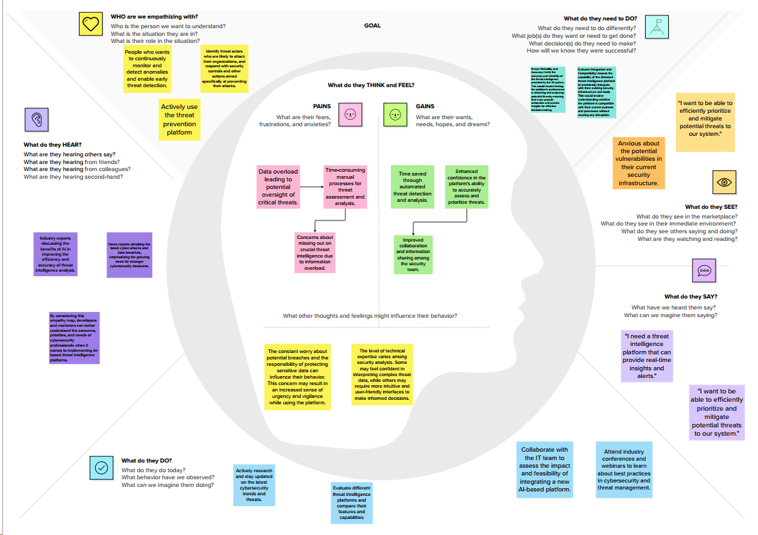

### Brainstorming Map

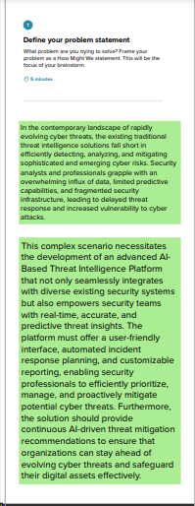 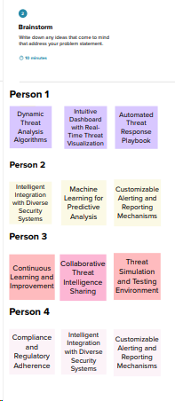

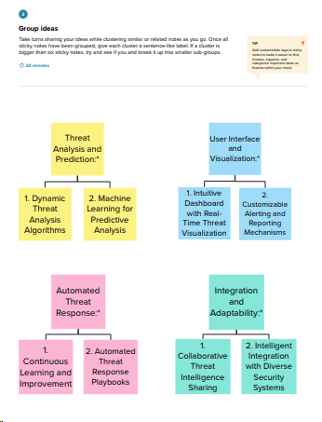 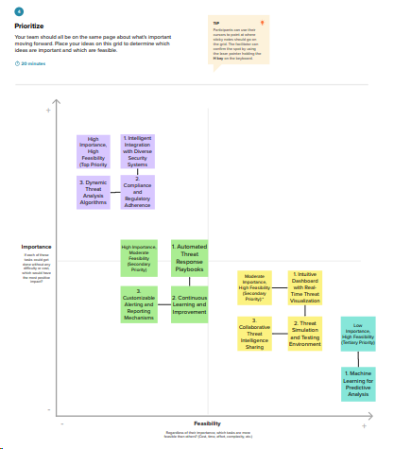

### 

### Proposed solution

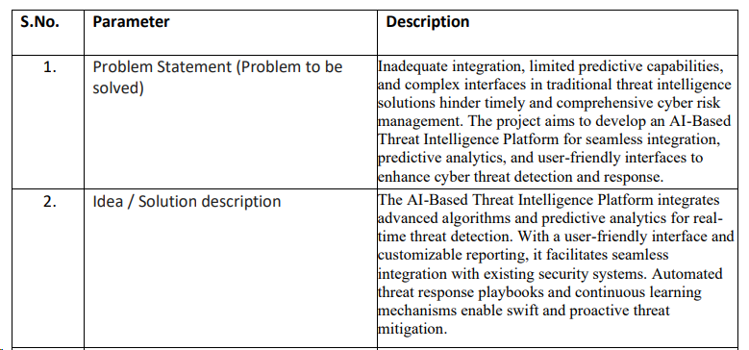

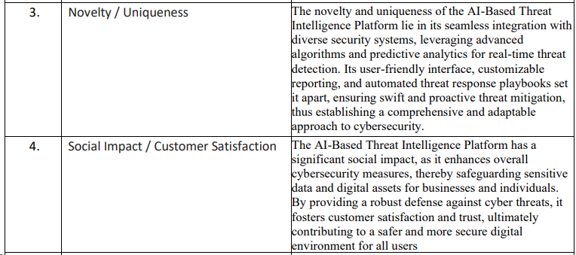

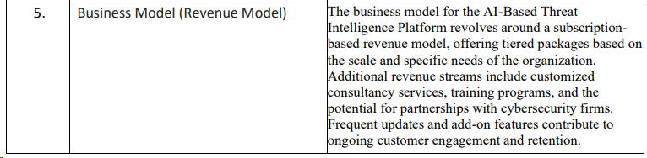

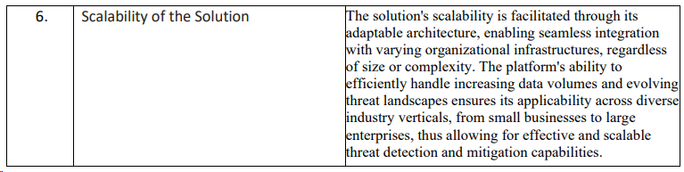

### Solution architecture

The solution architecture of an AI-based threat intelligence platform typically consists of the following components:

Data ingestion: This component is responsible for collecting security data from a variety of sources, such as system logs, network traffic, user behaviour, and external threat intelligence feeds. The data is then normalized and stored in a centralized location for analysis.

Data preprocessing: This component prepares the ingested data for machine learning by cleaning, transforming, and feature engineering.

Machine learning models: This component uses machine learning algorithms to analyse the pre-processed data and identify patterns and anomalies that may indicate potential threats.

Threat intelligence generation: This component converts the output of the machine learning models into human-readable and actionable threat intelligence reports.

Threat intelligence dissemination: This component distributes the threat intelligence reports to security analysts and other stakeholders across the organization.

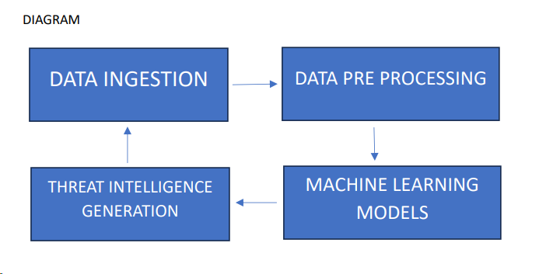

**Data ingestion:**

The data ingestion component collects security data from a variety of sources, such as:

* System logs (e.g., firewall logs, application logs, operating system logs).
* Network traffic (e.g., NetFlow data, packet captures).
* User behaviour data (e.g., login data, file access data, web browsing data).
* External threat intelligence feeds (e.g., feeds from security vendors, government agencies, and open-source sources).

**Data preprocessing**:

The data preprocessing component prepares the ingested data for machine learning by cleaning, transforming, and feature engineering. This may involve:

* Removing noise and outliers from the data.
* Transforming the data into a format that is compatible with the machine learning algorithms.
* Creating new features from the existing data that may be more predictive of potential threats.

**Machine learning models:**

The machine learning models component uses machine learning algorithms to analyse the pre-processed data and identify patterns and anomalies that may indicate potential threats. There are a variety of machine learning algorithms that can be used for this purpose, such as supervised learning, unsupervised learning, and deep learning.

**Threat intelligence generation:**

The threat intelligence generation component converts the output of the machine learning models into human-readable and actionable threat intelligence reports. This may involve:

* Correlating data from multiple sources to get a more complete picture of a threat.
* Enriching the data with additional information, such as the threat actor's motivations and capabilities.
* Prioritizing the threats based on their severity and impact to the organization.

### 

### Technology stack

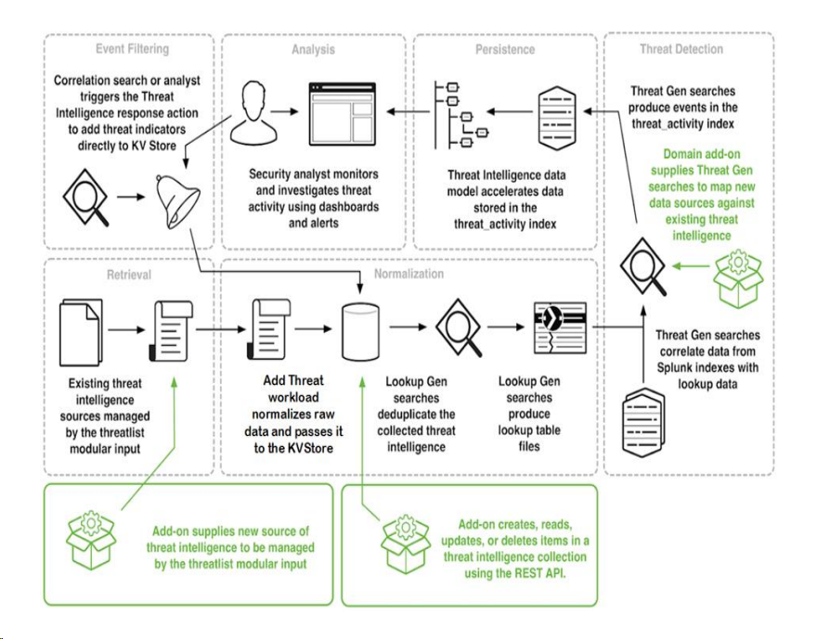

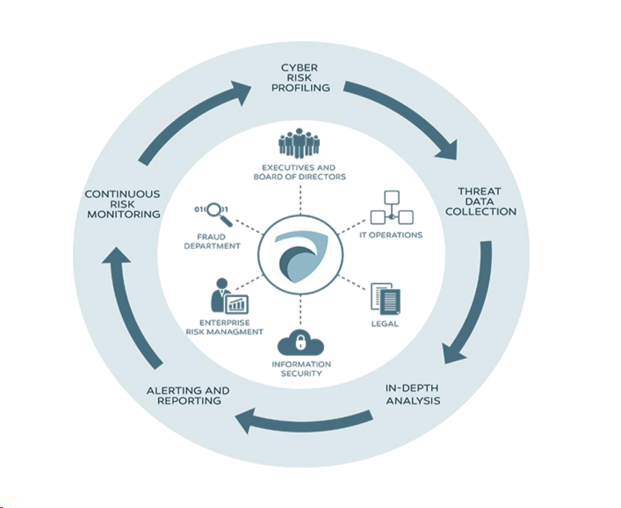

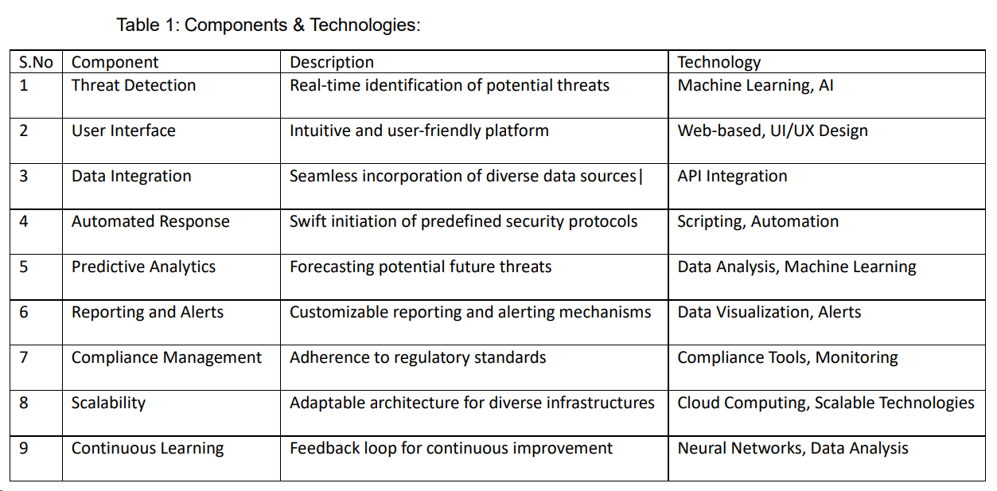

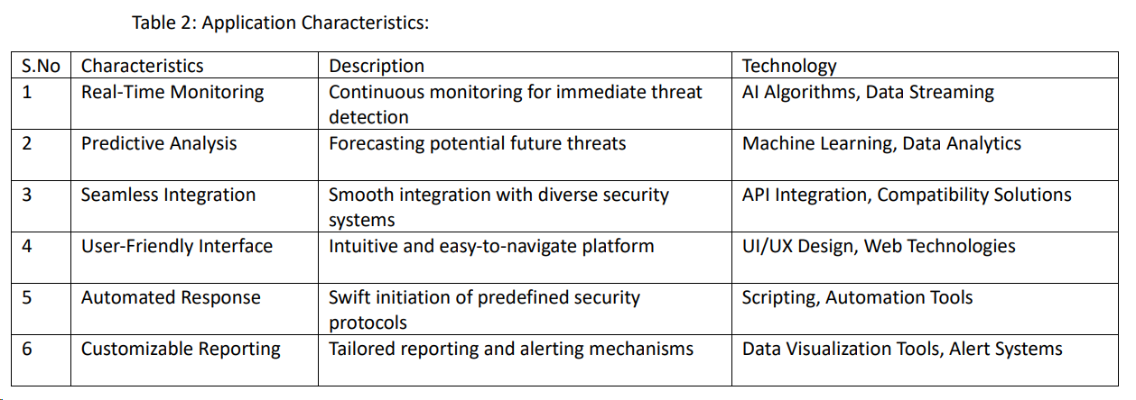

### Data flow

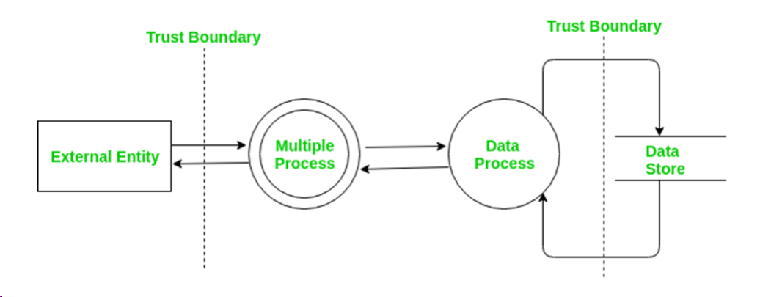

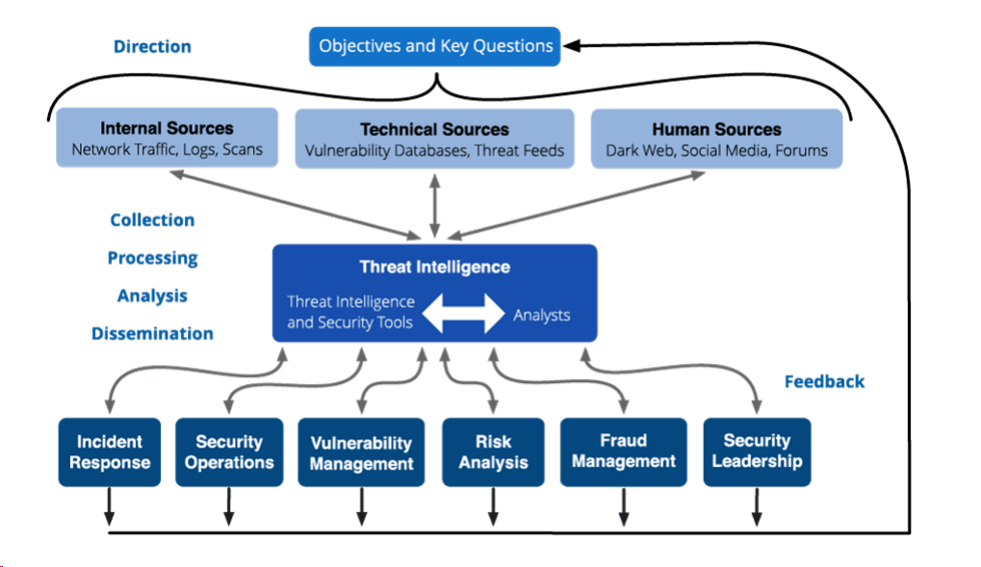

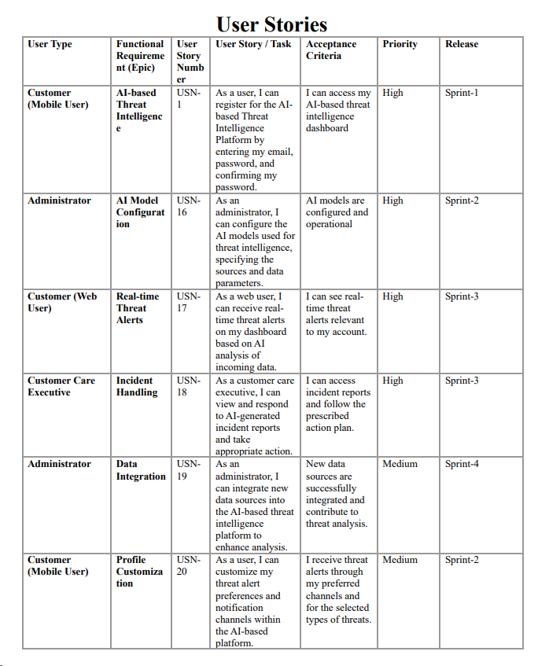

### Future Scope

* Advanced Machine Learning: Evolve machine learning models to stay ahead of emerging cyber threats and enhance threat detection accuracy.
* Automation: Expand automation capabilities for faster threat response, reducing manual intervention.
* IoT and Cloud Security: Extend coverage to address IoT and cloud security challenges as these domains grow in importance.
* Predictive Analysis: Develop predictive analytics to proactively identify potential threats based on historical data and emerging trends.
* Global Reach and Compliance: Broaden the platform's global footprint, ensuring it complies with evolving data protection regulations and cybersecurity needs worldwide.

### Conclusion

The AI-Based Threat Intelligence Platform is a dynamic solution that will continue to shape the future of cybersecurity. By leveraging advanced machine learning, automation, and the capability to adapt to emerging challenges, the platform offers a proactive defense strategy. It is poised to expand into new frontiers, addressing IoT and cloud security, implementing predictive analytics, and ensuring global compliance. As the cybersecurity landscape evolves, this platform stands ready to empower organizations, reduce data breach risks, and provide a robust line of defense against an ever-adapting spectrum of cyber threats.